Nushagak Chinook Salmon S/R Analysis

Internal ADF&G Memo

During the 2018 Escapement goal review cycle (Erickson et al. 2018), we discovered that there was a discrepancy in brood tables between those used to generate the 2012 escapement goal (Fair et al. 2012: Appendix A6) and those reported in ADF&G Buck et al. (2012 Appendix B6). We found that the brood table in Fair et al. (2012) expanded recruitment incorrectly, which resulted in higher recruitment per spawner than Buck et al (2012) (Erickson et al. 2018, Figure 1).

Figure 1: Comparison of productivity in recruits per spawner by brood year between the established Bendix/DIDSON conversion (Buck et al. 2012) and the incorrect dataset used in the 2012 escapement goal review (Fair et al. 2012).

Fortunately, this error did not greatly affect escapement goal range, and thus we did not propose changing of the 2012 escapement goal. But at the same time, the 2018 escapement goal review did not incorporate results of acoustic-tag and mark-recapture studies which showed the inriver run size estimate by DIDSON is underestimating “TRUE” Chinook salmon passage. In order to incorporate the two most recent tagging studies and all available historical data, the department has developed a run reconstruction model for Nushagak Chinook salmon (Head and Hamazaki, in prep).

Over the course of the Escapement Goal Review process, several recommendations were made on how the run reconstruction model could be improved. Recommendations include, adding in sport fish CPUE, adding in commercial catch CPUE, QAQC of historical data going into the model, investigating other data sources like towers and weirs, revisiting the Bendix/DIDSON conversion, and others. While we fully support further development of the model and believe that models should be under consistent review, for the purposes of this escapement goal review we have to pause model review and improvement at some point to complete the escapement goal review process. We have investigated incorporating sport fish CPUE into the model and while it does improve model performance, it is not to a point where it would change our recommendation surrounding the escapement goal. Due to the extensive work in documenting the run reconstruction and performing spawner recruit analysis with the version of the model prior to the addition of sport fish CPUE, we recommend documenting and continuing with the original version of the model for this escapement goal review and board cycle. After which we will begin a full model review and improvement process prior to the 2024 BOF and EG Review.

That being said, in this escapement goal review, we conducted 4 different spawner recruit datasets/timeseries using a Bayesian S/R model with AR1 Error. They include:

Model 1: SR data by Fair et al. 2012 (Appendix A): this is how the current escapement goal was set and it is based on the sonar index.

Model 2: SR data by Buck et al. 2012 (Appendix B): this was how the current escapement goal should have been set and is based on the sonar index.

Model 3: SR data by Buck et al. 2012 expanded (Appendix C): This is based on the sonar index with no incorporation of acoustic-MR.

Model 4: SR data by Head and Hamazaki (in prep) (Appendix D): Total run reconstruction model on a population level which is not directly comparable to the sonar index-based SR models.

|  |  |  |  |  |
| --- | --- | --- | --- | --- |
| Models | Model description | Escapement | Brood Years | Citation |
| Model 1 | Incorrect Recruitment: Current EG | DIDSON | 1966-2005 | Fair et al. 2012 |
| Model 2 | Model 1 + Correct Recruitment | DIDSON | 1966-2005 | Buck et al. 2012 |
| Model 3 | Model 2 + Extended data | DIDSON | 1968-2012 | Erickson et al. 2018 |
| Model 4 | Run reconstruction | Expanded DIDSON/ Run reconstruction | 1968-2012 | Head and Hamazaki in prep |

Table 1: Comparison of alternative models

All models were run using the same model parameters. A Bayesian Ricker model using AR(1) error was run for 10,000 simulations, with a burn-in length of 1,000, thinning of 10, and 1 chain. Results from the 4 models can be seen in Table 2, and details of each model run can be found in appendices A–D.

|  |  |  |  |  |
| --- | --- | --- | --- | --- |
| Table 2: Comparisons of 4 Spawner Recruit Models. | | | | |
|  | Model # | | | |
|  | 1 | 2 | 3 | 4 |
| Alpha | 5.556 | 5.047 | 4.436 | 4.536 |
| Beta | 0.752 | 0.740 | 0.716 | 0.542 |
| Phi | 0.580 | 0.422 | 0.420 | 0.544 |
| Smsy | 85,587 | 83,817 | 82,342 | 109,068 |
| Smax | 136,040 | 137,924 | 142,633 | 187,669 |
| Seq | 224,344 | 216,001 | 207,938 | 276,102 |

Note: Model 4 is population based while models 1-3 are based on the sonar index and are not directly comparable.

As expected, correcting recruitment (Model 1 vs. Model 2) lowered productivity (i.e Ricker alpha). Extending brood table to 2020 (Model 2 vs. Model 3) further lowered Ricker alpha, which reflects lower productivity in recent years. Reference parameters (Smsy, Smax, Seq) did not change greatly among the 3 models. Incorporating acoustic-mark recapture data changed characteristics of SR relationship (Model 3 vs. Model 4). However, the two model results were not comparable because unit of escapement differ. For more details, and EG analysis on each specific model see appendix A-D.

Rough conversion between DIDSON and Run reconstruction-based escapement are:

DIDSON to Run reconstruction (R2 = 0.86)

RR ESC = 3,870+1.4*(DIDSON ESC)

Run reconstruction to DIDSON (R2 = 0.86)

DIDSON ESC = 20,018+0.62*(RR ESC)

Using the above equations, Smsy of Model 4 (109,068) corresponds to 87,204 of Model 3 equivalent, or that of Model 3 (82,342) corresponds to 118,802 of Model 4 equivalent.

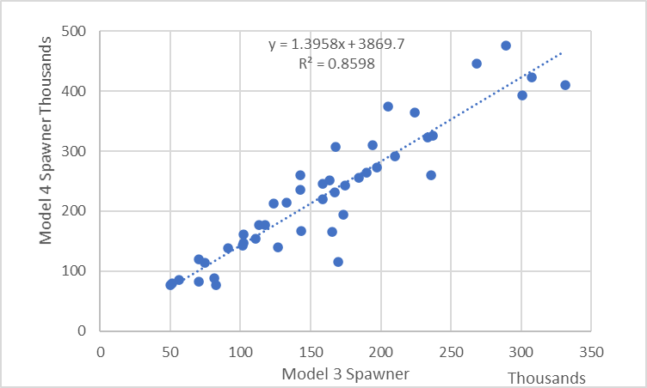 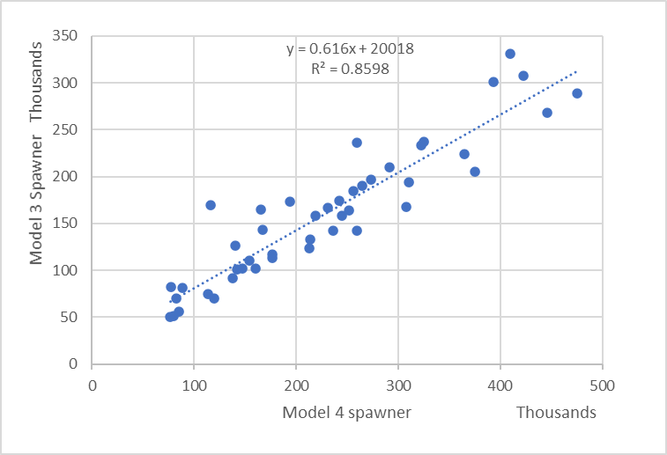

**Recommendation:**

Our recommendation at this point is no change to the current goal. However, we do recommend that we establish what the goal range would be based on the run reconstruction and track that goal on a trial basis through this next cycle while the model is under review. The current escapement goal is set at 55,000 – 120,000 fish while model 3 recommends a goal of 48,000 – 116,000 which would be slightly lowering the goal (Appendix B & C). Model 4 recommends a run reconstruction-based goal of 65,500 – 152,500 fish, however this goal is not directly comparable to the sonar-based goals. When a sonar equivalent goal is calculated using model 4, a sonar equivalent goal of 58,800 – 114,600 is recommended. When comparing the three goals, we can see that they all fall right around the current goal range of 55,000 – 120,000 fish.

**Works Cited**

Buck, G.B., Brazil, C.B., West, F., Fair, L.F., Zhang, X., and S.L. Maxwell. 2012. Stock assessment of Chinook, sockeye and chum salmon in the Nushagak River. Alaska Department of Fish and Game, Fishery Management Series No. 12-05, Anchorage.

Erickson, J. W., G. B. Buck, T. R. McKinley X. Zhang, T. Hamazaki, and A.B. St. Saviour. 2018. Review of salmon escapement goals in Bristol Bay, Alaska, 2018. Alaska Department of Fish and Game, Fishery Manuscript No. 18-06, Anchorage.

Fair, L. F., C. E. Brazil, X. Zhang, R. A. Clark, and J. W. Erickson. 2012. Review of salmon escapement goals in Bristol Bay, Alaska, 2012. Alaska Department of Fish and Game, Fishery Manuscript Series No. 12-04, Anchorage.

Head, J., T. Hamazaki. 20XX. 1968–2020 Nushagak River Chinook salmon run reconstruction. Alaska Department of Fish and Game, Fishery Data Series No. YY-XX, Anchorage.

**Appendix A. Spawner Recruit model results for 2012 Bendix/DIDSON conversion dataset with data errors included. (this is how the current escapement goal was set)**

* Model Parameters:
  + Ricker Model
  + AR(1) Error
  + Simulations = 10,000
  + Burn-in length = 1,000
  + Thinning = 10
  + Number of Chains = 1
* Smsy = 85,587 *90% CI* (71,478–101,680)
* SMAX =136,040 *90% CI* (107,304–175,444)
* SEQ = 224,344 *90% CI* (182,384–271,232)
* Alpha = 5.556 *90% CI* (3.483–8.383)
* Ln Alpha = 1.679 *90% CI* (1.248–2.126)
* Beta = 0.752 *90% CI* (0.570–0.932)
* Phi = 0.58 *95% CI* (0.256–0.900)

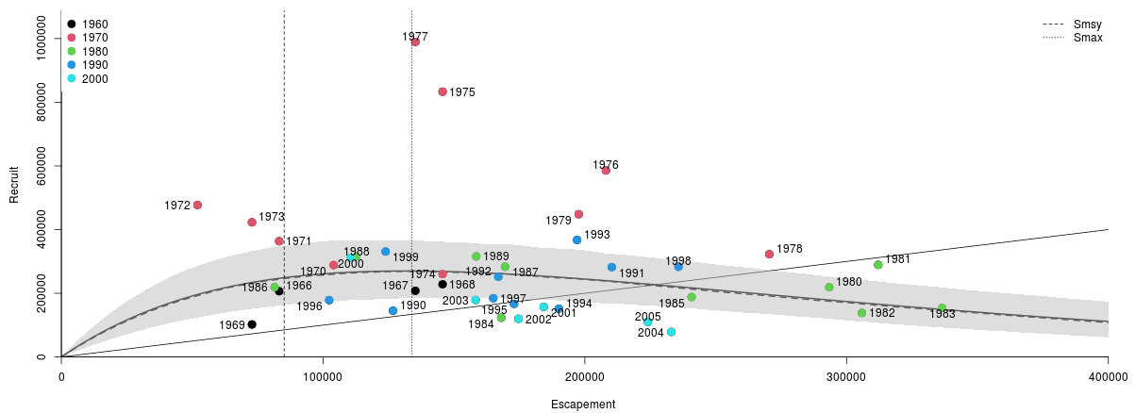

Appendix A1: Spawner Recruit plot for 2012 Bendix/Didson data set with incorrect return info. This is the dataset that set the 2012 Escapement goal.

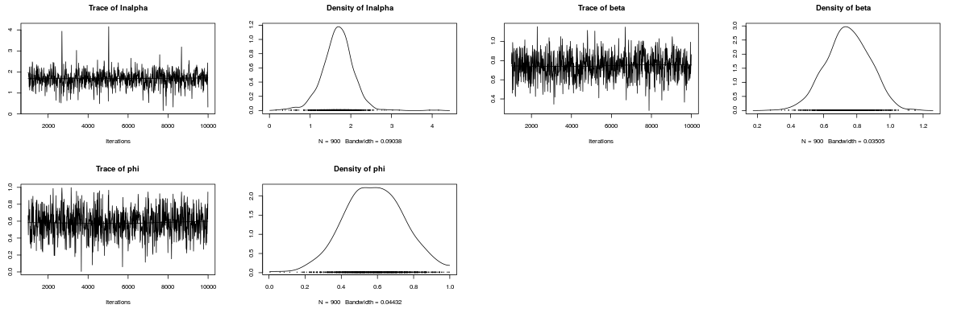

Appendix A2: Trace plots for Bayesian Ricker Spawner Recruit Model.

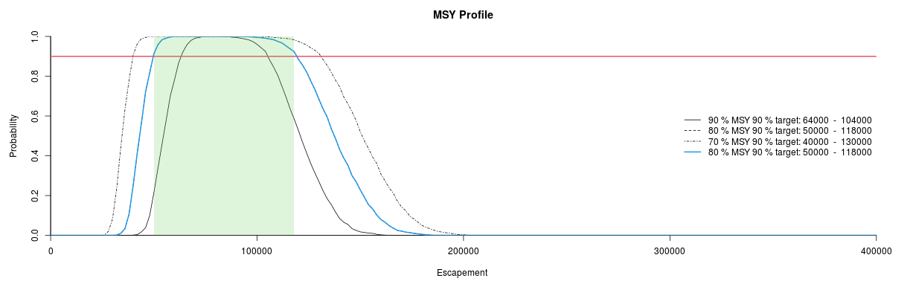

Appendix A3: Smsy Profile, green shaded area represents 80% of Smsy 90% target.

**Smsy range analysis**

90% MSY achieving 90% Probability: 64,000 – 104,000

80% MSY achieving 90% Probability: 50,000 – 118,000

70% MSY achieving 90% Probability: 40,000 – 130,000

Appendix A6: Dataset from Fair et al. (2012)



**Appendix B. Spawner Recruit Model Results for 2012 Bendix/DIDSON conversion dataset with corrected data errors. (this is the results from the data set that should have been used to generate the 2012 escapement goal)**

* Model Parameters:
  + Ricker Model
  + AR(1) Error
  + Simulations = 10,000
  + Burn-in length = 1,000
  + Thinning = 10
  + Number of Chains = 1
* Smsy = 83,817 *90% CI* (73,170–96,401)
* SMAX =137,924 *90% CI* (109,936–174,929)
* SEQ = 216,001 *90% CI* (185,028–246,715)
* Alpha = 5.047 *90% CI* (3.355–7.253)
* Ln Alpha = 1.593 *90% CI* (1.210–1.981)
* Beta = 0.740 *90% CI* (0.572–0.910)
* Phi = 0.42 *95% CI* (0.040–0.800)

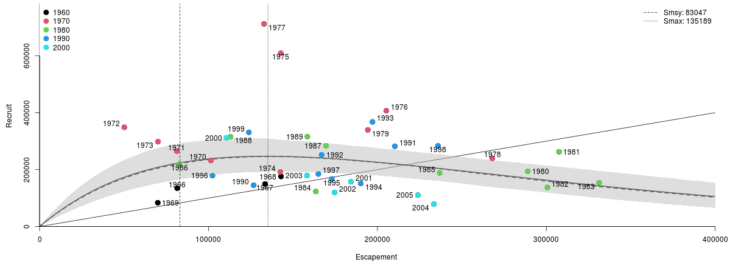

Appendix B1: Spawner Recruit plot for 2012 Bendix/Didson data set with incorrect return info. This is the dataset that set the 2012 Escapement goal.

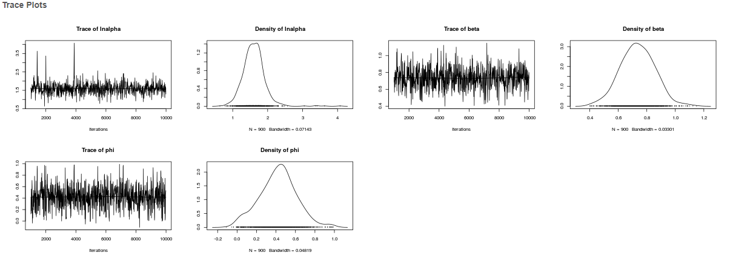

Appendix B2: Trace plots for Bayesian Ricker Spawner Recruit Model.

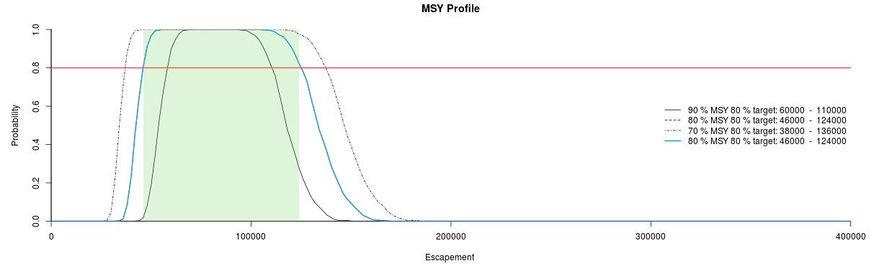

Appendix B3: Smsy Profile, green shaded area represents 80% of Smsy 90% target.

**Smsy range analysis**

90% MSY achieving 90% Probability: 60,000 – 110,000

80% MSY achieving 90% Probability: 46,000 – 124,000

70% MSY achieving 90% Probability: 38,000 – 136,000

Appendix B6: Dataset from Buck et al. (2012)



**Appendix C. Spawner Recruit Model Results for Bendix/DIDSON conversion dataset updated with most recent 8 years.**

* Model Parameters:
  + Ricker Model
  + AR(1) Error
  + Simulations = 10,000
  + Burn-in length = 1,000
  + Thinning = 10
  + Number of Chains = 1
* Smsy = 82,342 *90% CI* (70,621–95,481)
* SMAX =142,633 *90% CI* (111,980–180,388)
* SEQ = 207,938 *90% CI* (176,033–240,131)
* Alpha = 4.486 *90% CI* (3.169–6.170)
* Ln Alpha = 1.481 *90% CI* (1.153–1.820)
* Beta = 0.716 *90% CI* (0.554–0.893)
* Phi = 0.42 *95% CI* (0.028–0.774)

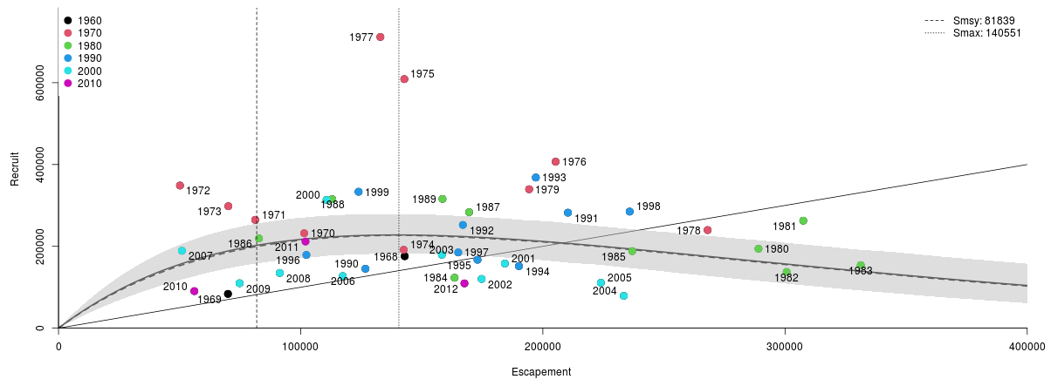

Appendix C1: Spawner Recruit plot for 2012 Bendix/Didson data set with incorrect return info. This is the dataset that set the 2012 Escapement goal.

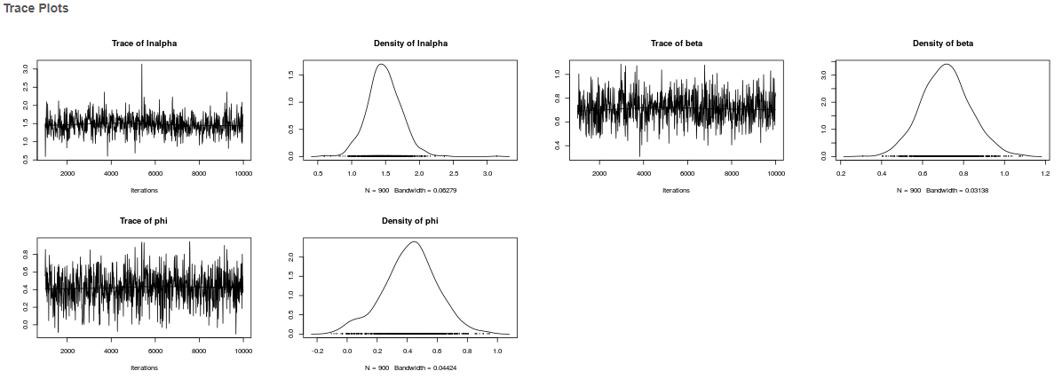

Appendix C2: Trace plots for Bayesian Ricker Spawner Recruit Model.

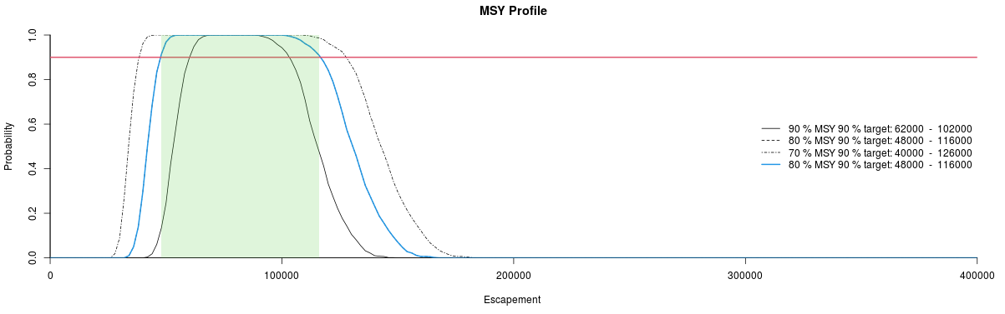

Appendix C3: Smsy Profile, green shaded area represents 80% of Smsy 90% target.

**Smsy range analysis**

90% MSY achieving 90% Probability: 62,000 – 102,000

80% MSY achieving 90% Probability: 48,000 – 116,000 Current Goal = 55,000 – 120,000

70% MSY achieving 90% Probability: 40,000 – 126,000

|  |  |  |  |
| --- | --- | --- | --- |
| Appendix C6: Buck et al. (2012) updated through 2020. | | | |
| Brood Year | Spawning Escapement | Total Return | Return per spawner |
| 1968 | 142,951 | 175,766 | 1.23 |
| 1969 | 69,970 | 83,613 | 1.19 |
| 1970 | 101,435 | 231,916 | 2.29 |
| 1971 | 81,237 | 264,749 | 3.26 |
| 1972 | 50,156 | 348,612 | 6.95 |
| 1973 | 70,130 | 297,989 | 4.25 |
| 1974 | 142,535 | 191,584 | 1.34 |
| 1975 | 142,791 | 608,764 | 4.26 |
| 1976 | 205,273 | 406,883 | 1.98 |
| 1977 | 132,907 | 711,779 | 5.36 |
| 1978 | 268,046 | 239,702 | 0.89 |
| 1979 | 194,335 | 339,511 | 1.75 |
| 1980 | 289,040 | 194,006 | 0.67 |
| 1981 | 307,527 | 262,577 | 0.85 |
| 1982 | 300,656 | 137,337 | 0.46 |
| 1983 | 331,270 | 153,903 | 0.46 |
| 1984 | 163,544 | 123,104 | 0.75 |
| 1985 | 236,899 | 188,254 | 0.79 |
| 1986 | 82,777 | 219,175 | 2.65 |
| 1987 | 169,562 | 283,449 | 1.67 |
| 1988 | 113,006 | 315,143 | 2.79 |
| 1989 | 158,551 | 315,785 | 1.99 |
| 1990 | 126,747 | 145,149 | 1.15 |
| 1991 | 210,346 | 282,201 | 1.34 |
| 1992 | 166,965 | 252,253 | 1.51 |
| 1993 | 197,098 | 368,161 | 1.87 |
| 1994 | 190,121 | 151,531 | 0.80 |
| 1995 | 173,014 | 167,131 | 0.97 |
| 1996 | 102,348 | 178,920 | 1.75 |
| 1997 | 165,062 | 185,066 | 1.12 |
| 1998 | 235,845 | 284,847 | 1.21 |
| 1999 | 123,906 | 333,344 | 2.69 |
| Continued. | | | |

|  |  |  |  |
| --- | --- | --- | --- |
| Appendix C6 Continued | |  |  |
| Brood Year | Spawning Escapement | Total Return | Return per spawner |
| 2000 | 110,682 | 313,352 | 2.83 |
| 2001 | 184,317 | 157,782 | 0.86 |
| 2002 | 174,704 | 120,171 | 0.69 |
| 2003 | 158,307 | 179,369 | 1.13 |
| 2004 | 233,475 | 78,789 | 0.34 |
| 2005 | 223,950 | 110,790 | 0.49 |
| 2006 | 117,364 | 127,187 | 1.08 |
| 2007 | 50,960 | 189,016 | 3.71 |
| 2008 | 91,364 | 134,849 | 1.48 |
| 2009 | 74,781 | 109,686 | 1.47 |
| 2010 | 56,092 | 90,383 | 1.61 |
| 2011 | 101,995 | 211,679 | 2.08 |
| 2012 | 167,618 | 109,294 | 0.65 |
| 1968-2012 Average | 159,815 | 230,546 | 1.79 |
| No. of Years | 45 | 45 | 45 |
| a Spawning escapement is defined as the sonar count minus sport and subsistence harvest occurring above the counting sonar (Buck et al. 2012). | | | |

**Appendix D. Spawner Recruit Model Results for Nushagak Chinook salmon Run Reconstruction dataset though 2020.**

(Note: This analysis uses run reconstruction population estimates which are not directly comparable to the sonar based indices used in appendix A – C)

* Model Parameters:
  + Ricker Model
  + AR(1) Error
  + Simulations = 10,000
  + Burn-in length = 1,000
  + Thinning = 10
  + Number of Chains = 1
* Smsy = 109,068 *90% CI* (93,114–125,533)
* SMAX =187,669 *90% CI* (151,886–234,079)
* SEQ = 276,102 *90% CI* (231,577–319,337)
* Alpha = 4.536 *90% CI* (3.168–6.257)
* Ln Alpha = 1.491 *90% CI* (1.153–1.834)
* Beta = 0.542 *90% CI* (0.427–0.658)
* Phi = 0.544 *95% CI* (0.209–0.855)

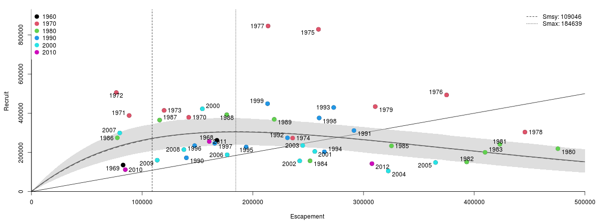

Appendix D1: Spawner Recruit plot for 2012 Bendix/Didson data set with incorrect return info. This is the dataset that set the 2012 Escapement goal.

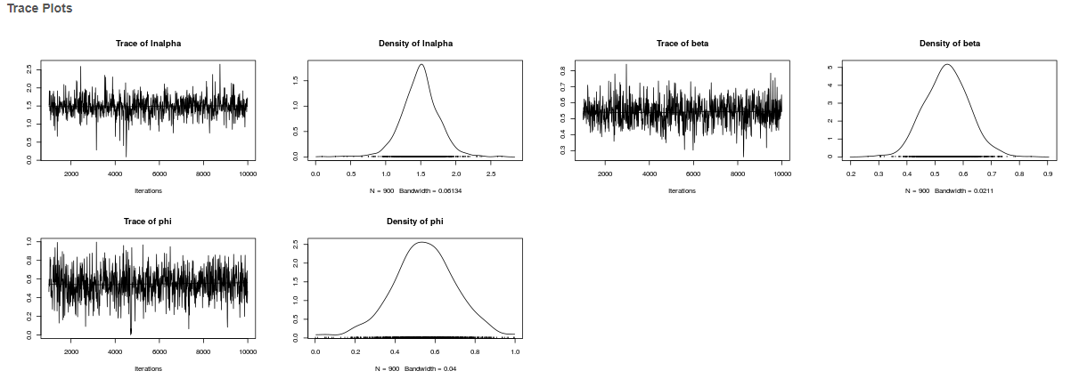

Appendix D2: Trace plots for Bayesian Ricker Spawner Recruit Model.

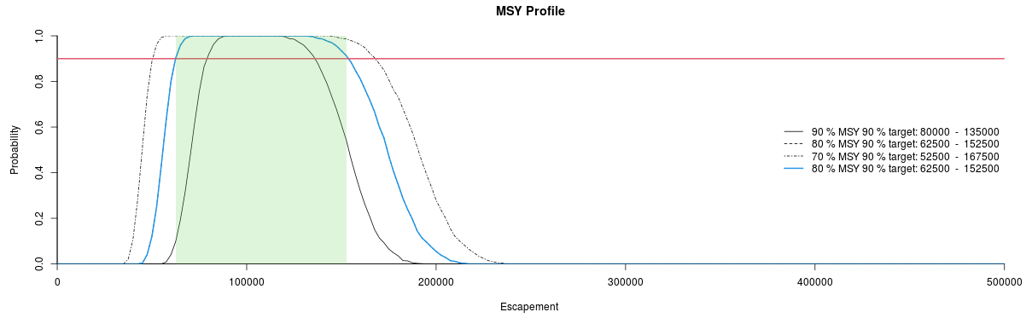

Appendix D3: Smsy Profile, green shaded area represents 80% of Smsy 90% target.

**Smsy range analysis (Current Goal 55,000 – 120,000 based on sonar index)**

90% MSY achieving 90% Probability: 80,000 – 135,000

80% MSY achieving 90% Probability: 62,500 – 152,500 **(Sonar equivalent goal 58,800 – 114,600)**

70% MSY achieving 90% Probability: 52,500 – 167,500

|  |  |  |  |
| --- | --- | --- | --- |
| Appendix D6: Head and Hamazaki (in prep) Nushagak Chinook salmon run reconstruction dataset. | | | |
| Year | Spawning Escapement | Total Return | Return per spawner |
| 1968 | 167,570 | 261,876 | 1.56 |
| 1969 | 82,809 | 135,449 | 1.64 |
| 1970 | 142,080 | 379,022 | 2.67 |
| 1971 | 88,263 | 388,326 | 4.40 |
| 1972 | 76,653 | 505,638 | 6.60 |
| 1973 | 119,850 | 414,356 | 3.46 |
| 1974 | 235,980 | 273,159 | 1.16 |
| 1975 | 259,300 | 828,438 | 3.19 |
| 1976 | 375,010 | 493,173 | 1.32 |
| 1977 | 213,740 | 845,434 | 3.96 |
| 1978 | 445,770 | 303,575 | 0.68 |
| 1979 | 310,560 | 433,921 | 1.40 |
| 1980 | 475,580 | 218,969 | 0.46 |
| 1981 | 423,140 | 241,292 | 0.57 |
| 1982 | 393,210 | 151,205 | 0.38 |
| 1983 | 409,800 | 200,440 | 0.49 |
| 1984 | 251,710 | 156,828 | 0.62 |
| 1985 | 325,250 | 233,383 | 0.72 |
| 1986 | 77,577 | 274,521 | 3.54 |
| 1987 | 115,790 | 365,241 | 3.15 |
| 1988 | 176,470 | 392,258 | 2.22 |
| 1989 | 219,340 | 368,651 | 1.68 |
| 1990 | 140,000 | 172,336 | 1.23 |
| 1991 | 291,360 | 311,669 | 1.07 |
| 1992 | 231,280 | 274,476 | 1.19 |
| 1993 | 273,030 | 429,338 | 1.57 |
| 1994 | 264,610 | 202,904 | 0.77 |
| 1995 | 193,990 | 227,467 | 1.17 |
| 1996 | 147,390 | 234,737 | 1.59 |
| 1997 | 165,560 | 246,244 | 1.49 |
| 1998 | 259,930 | 375,790 | 1.45 |
| 1999 | 213,310 | 448,786 | 2.10 |
| Continued. | | | |

|  |  |  |  |
| --- | --- | --- | --- |
| Appendix D6 Continued | |  |  |
| Year | Spawning Escapement | Total Return | Return per spawner |
| 2000 | 154,440 | 422,478 | 2.74 |
| 2001 | 255,950 | 204,736 | 0.80 |
| 2002 | 242,350 | 156,578 | 0.65 |
| 2003 | 245,050 | 235,308 | 0.96 |
| 2004 | 322,340 | 105,190 | 0.33 |
| 2005 | 365,040 | 148,479 | 0.41 |
| 2006 | 176,770 | 187,958 | 1.06 |
| 2007 | 79,768 | 299,154 | 3.75 |
| 2008 | 137,740 | 214,351 | 1.56 |
| 2009 | 113,610 | 160,183 | 1.41 |
| 2010 | 84,770 | 112,026 | 1.32 |
| 2011 | 160,630 | 255,521 | 1.59 |
| 2012 | 307,600 | 142,527 | 0.46 |
| 1968-2012 Average | 226,933 | 298,520 | 1.70 |
| No. of Years | 45 | 45 | 45 |